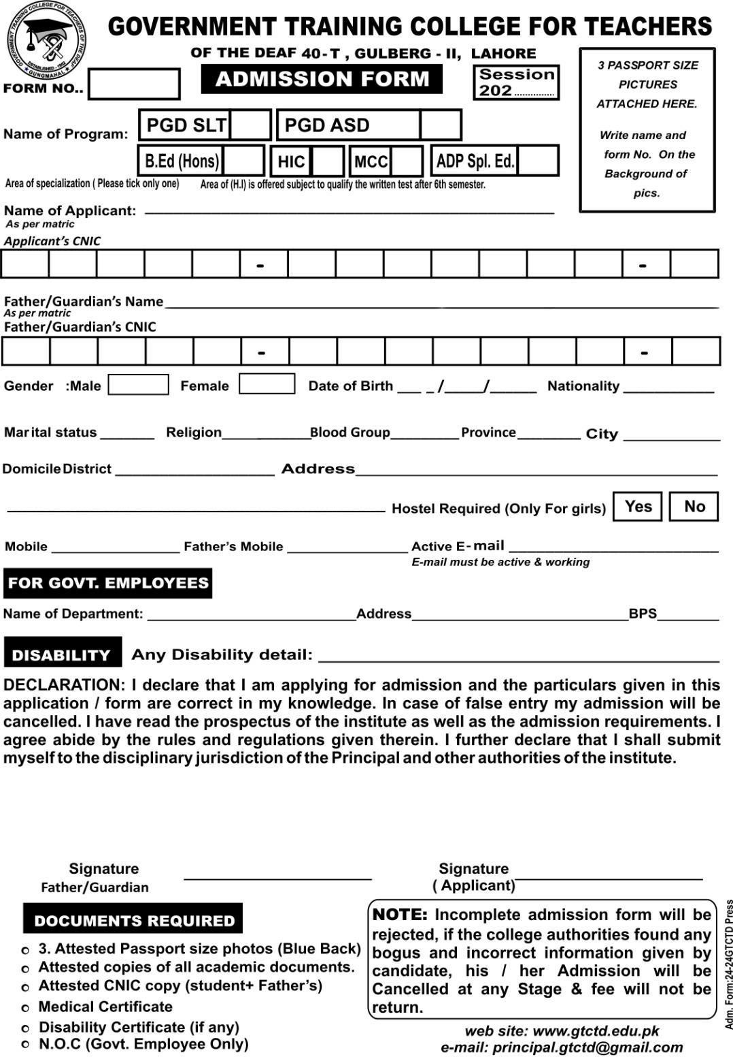

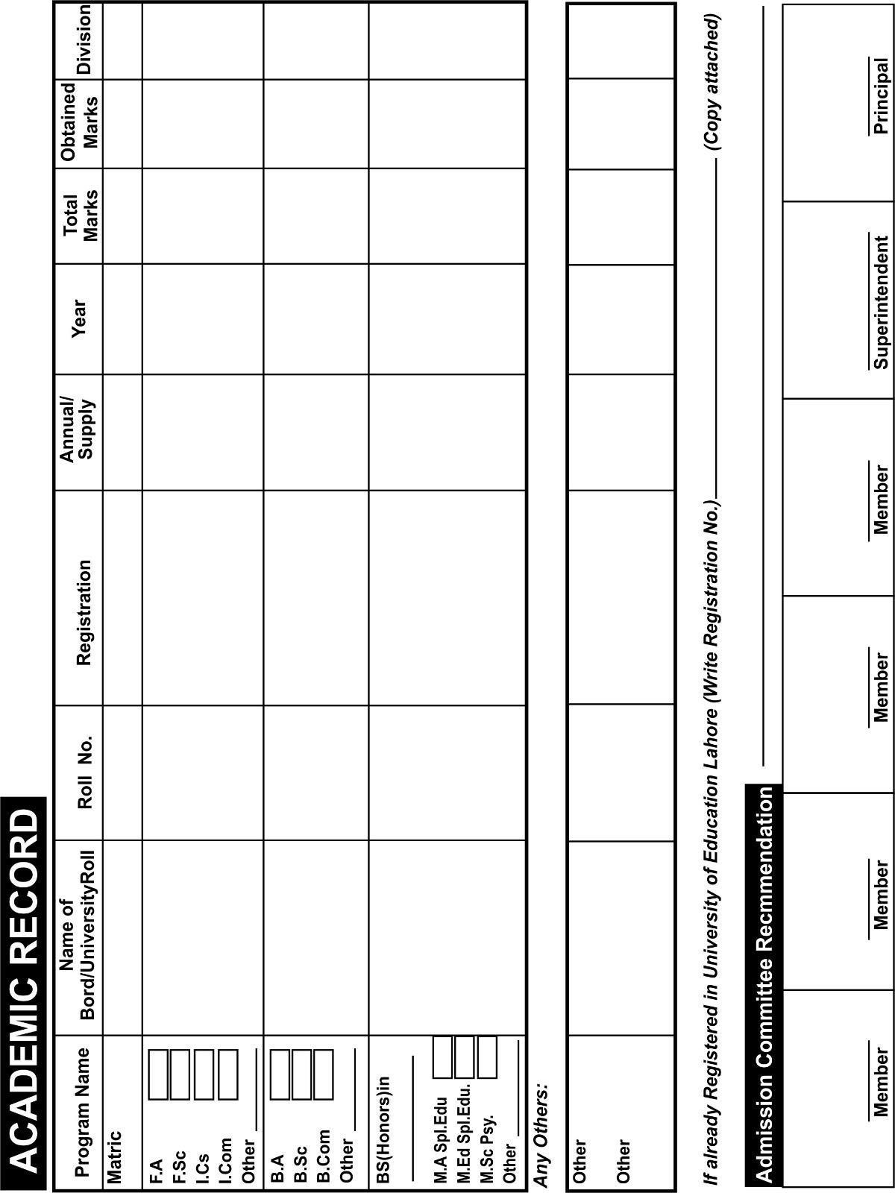

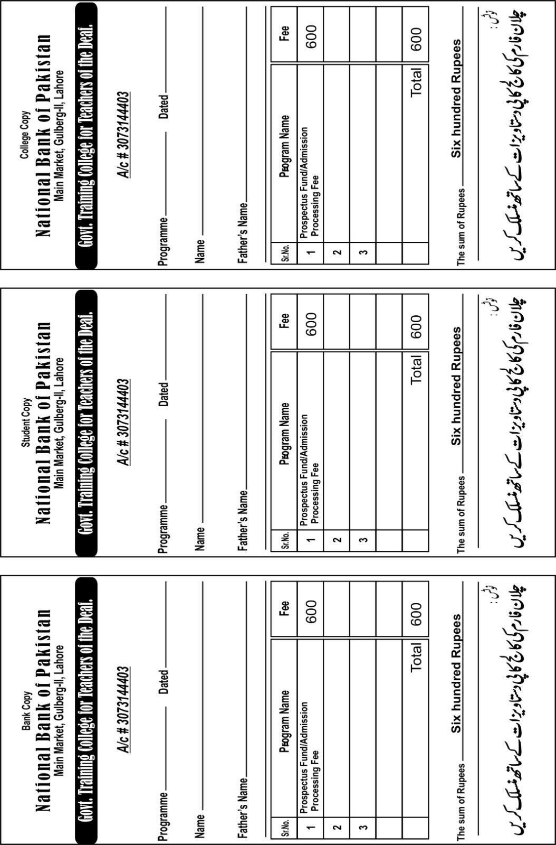

# DECLARATION BY APPLICANT

**(For Admission as Result Awaiting Applicant)**

1. I intend to apply for admission at the Govt. Training College for Teachers of the Deaf, Gulberg-II, Lahore based on the hope that I will pass the examination with the marks as prescribed in the admission eligibility of a program.
2. I will provide the official result card/marks sheet to the Admission Office, the Government Training College for Teachers of the Deaf, Lahore within 05 days after the result declaration, otherwise, the college has the right to cancel my admission without any prior notice.
3. The college may cancel my admission if the undersigned fails to obtain less marks in Matric/Intermediate/Equivalent examination as per admission eligibility criteria.
4. However, the claim for refund of deposited dues will be returned after 15days of completion of admission process. (In case of cancellation of admission)

|  |  |
| --- | --- |
| **Name of Applicant** |  |
| **CNIC of Applicant** |  |
| **Signature of Applicant** |  |
| **Study Program** |  |
| **Name of Father/Guardian** |  |
| **CNIC of Father/Guardian** |  |

# Signature of Father/Guardian

NOTE:

Follow the following steps to apply for admission.

* 1. Fill the admission for i.e page 1and2.
  2. Print out the Declaration form on Rupees 100 E-Stamp Paper i.e page4.
  3. Submit the Admission Processing Fee Amount 600/- on prescribed Challan form Attached i.e page3.
  4. Attached all documents with admission form mention in page1 including paid challan form amount Rs.600/- and declaration on E stamp and submitted with Admission Fee.

|  |  |  |  |
| --- | --- | --- | --- |
|  | | | |
|  | **Admission Eligibility Criteria (Fall 2025)** | | |
| **Sr. #** | **Name of Program** | **Admission Requirements / Basic Eligibility Criteria** |
| 1 | B.Ed. (4 Years) Special Education | Duration of program is 4 years (8th Semesters)  A Higher Secondary School Certificate or equivalent degree with minimum 2nd Division |
| 2 | Post Graduate Diploma Autism Spectrum Disorder | Duration of program is 15month.  2 Semester and 3months months clinical practice.   1. Admission will be on merit. 2. MA Special Education (min. 2nd Division) 3.M.Ed. Special Education (min. 2nd Division)   4.MSc Psychology (min. 2nd Division), 5.B.Ed. Hons in Special Education  6.BS Hons in Special Education |
| 3 | Post Graduate Diploma in Speech and Language Therapy | Duration of program is 15month.  2 Semester and 3months months clinical practice.   1. Admission will be on merit. 2. MA Special Education (min. 2nd Division) 3.M.Ed. Special Education (min. 2nd Division)   4.MSc Psychology (min. 2nd Division), 5.B.Ed. Hons in Special Education  6.BS Hons in Special Education  7.MA/MSc along with Teaching of Deaf Diploma with minimum 2nd division |
|  | | | |
|  | **Fee Structure** | | |
| **Sr. #** | **Name of Program** | **FEE** |
| 1 | B.Ed. (4 Years) Special Education | 1st Semester 15350 5th Semester 7750  2nd Semester 5050 6th Semester 5050  3rd Semester 7750 7th Semester 7750  4th Semester 5050 8th Semester 5050 |
| 2 | Post Graduate Diploma Autism Spectrum Disorder | 1. 1st Semester Fee 29400 2. 2nd Semester Fee 15800 3. 3months clinical practice Fee 5000   Total = 50200 |
| 3 | Post Graduate Diploma in Speech and Language Therapy | 1.20900 for Complete Program  2. Total fee 20900 will be submitted at time of admission. |
| pg. 6 | | | |